Lab 5  
Pengzhao Zhu   
Section: 112D

B) Prelab Questions

1. What are some examples of useful macro functions, in the context of this lab?

**An example of a useful macro function is the use of #define (function-like macro) to take in arguments. This is then preprocessed so when I have to use that definition again later in the lab, I don’t have to keep typing in. For example, I can do “#define hello(X) for(int i = 0; i < X; i++)”. This code is good for when I have to use it for strings in Part A. Other similar macro functions can also be used to simplify coding process (while loop is another one).**

1. Why do we use UART to communicate with the Atmel Studio Data Visualizer extension program?

**We have to get the data from the accelerometer to the Data Visualizer. We need to use the UART system (UART is actually physically connected to the computer through the USB) to get the information to Atmel Studio Data Visualizer.**

1. What is the highest speed of communication that the IMU can handle?

**10 MHZ**

1. Why is it a better idea to modify global flag variables inside of ISRs instead of doing everything inside of them?

**In general, a program should spend as little time as possible in the interrupt service routine as we want the program to be interrupted as little as possible. So it is better to just modify global flag variables inside of ISRs instead of doing everything inside of them.**

1. Why is the “-D” tag used within the Data Stream Protocol defined in data_stream_protocol.txt?

**The “-D” determines the type of data used for that particular stream going towards the data stream visualizer. -D means signed short.**

1. What is the most positive value that can be received from the accelerometer (in decimal)? What about the most negative?

**-D is a signed short. So -32,768 (negative) to 32,767 (positive).**

C) Problems Encountered

The first problem I encountered in this lab was the use of C programming. It took me a while to get used to C syntax and understand how to use functions in C. I had to do a lot of research online to understand the different data types and pointers in C.

One other major problem I encountered in this lab was configuring the accelerometer. It was very difficult to find all the control signals between the port connections and the accelerometer. I had to go very deep in the schematics and the LSM specifications to complete this lab.

D) Future Application

By completing this lab, I gained more knowledge of the SPI and UART system. Using SPI and USART (asynchronous mode), I can communicate with other communication devices with microcontrollers. This skill is very important when it comes to future projects where I need to work with multiple devices at once. For example, I might have to use microcontrollers to control robots in senior design or I might have to use SPI at my future engineering job.

E) Schematics

N/A

# 

# F) Pseudocode/Flowcharts

**Part A1 Pseudocode**

Call function to initialize 32 Mhz clock

Call function to initialize USART

a=”U’

while(1) {

OUT_CHAR(a);

}

*USART Initialization code

*32 MHZ initialization code

*OUT_CHAR function to output data to putty

*OUT_STRING function to output strings to putty

* IN-CHAR function to take in information from the keypad

**Part A2 Pseudocode**

Call function to initialize 32 Mhz clock

Call function to initialize USART

Set red LED as output

Turn off red LED

CHECK:;

Read data from IN_CHAR

OUT_CHAR character

if ((character != 'R') && (character !='r')) {

goto CHECK;

}

Read data from IN_CHAR

OUT_CHAR character

if ((character != 'E') && (character != 'e')){

goto CHECK;

}

Read data from IN_CHAR

OUT_CHAR character

if ((character != 'D') && (character != 'd')){

goto CHECK;

}

PORTD_OUTTGL=0x10;

goto CHECK;

*USART Initialization code

*32 MHZ initialization code

*OUT_CHAR function to output data to putty

*OUT_STRING function to output strings to putty

* IN-CHAR function to take in information from the keypad

**Part B Pseudocode**

int main(void){

//nothing in the main. This program just contain functions that we need later

while(1) {

}

};

* Function to initialize SPI

- Set input, output signals, SPIF_CTRL

*Function to write using SPI

*Function to read using SPI

*Function to initialize 32 MHZ clock

**Part C Pseudocode**

int main(void){

CLK_32MHZ();

SPI(); //call function to initialize SPI

while(1){

SPI_WRITE(0x53);

}

return 0;

*Function to initialize SPI  
*Function to write using SPI

*Function to read using SPI

*Function to initialize 32MHZ clock

**Part D Pseudocode**

int main(void){

CLK_32MHZ();

SPI(); //call function to initialize SPI

uint8_t hello;

hello=ACCEL_READ(WHO_AM_I_A);

while(1);

return 0;

}

*Function to initialize SPI  
*Function to write using SPI

*Function to read using SPI

*Function to initialize 32MHZ clock

*void ACCEL_WRITE(uint8_t addr, uint8_t data)-Function to write to the accelerometer. First byte will determine write/read and the address. Each byte will contain the data that we want to write to the accelerometer

*uint8_t ACCEL_READ(uint8_t addr)- Function to read to the accelerometer. Within the function, we will first write a garbage byte to accelerometer. Then we will read from it

**Part E Pseudocode**

int main(void){

CLK_32MHZ();

SPI(); //call function to initialize SPI

uint8_t hello; //most are carry over code from Part D

hello=ACCEL_READ(WHO_AM_I_A);

while(1);

return 0;

}

*Function to initialize SPI  
*Function to write using SPI

*Function to read using SPI

*Function to initialize 32MHZ clock

*void ACCEL_WRITE(uint8_t addr, uint8_t data)-Function to write to the accelerometer. First byte will determine write/read and the address. Each byte will contain the data that we want to write to the accelerometer

*uint8_t ACCEL_READ(uint8_t addr)- Function to read to the accelerometer. Within the function, we will first write a garbage byte to accelerometer. Then we will read from it

* void ACCEL_INIT(void){

enable low level interrupt

set pin 7 on C as source for interrupt

set pin 7 as input

rising edge trigger

enable low level interrupt in the PMIC

enable global interrupt flag

resetting the LSM system using ACCEL_WRITE

Write to the accelerometer to set up INT_A, interrupt signal, and trigger edge using ACCEL_WRITE

Write to the accelerometer to determine output rate, BDU, and enable XYZ plot data

}

**Part F Pseudocode**

*before MAIN. Set up a global volatile variable to determine when to write to data visualizer

int main(void){

CLK_32MHZ();

SPI(); //call function to initialize SPI

Call function to initialize USART

while(intbit != 1); //keep checking if the interrupt is set

XL= ACCEL_READ (OUT_X_L_A); //read measurements from accelerometer

XH= ACCEL_READ (OUT_X_H_A);

YL= ACCEL_READ(OUT_Y_L_A);

YH= ACCEL_READ(OUT_Y_H_A);

ZL= ACCEL_READ(OUT_Z_L_A);

ZH= ACCEL_READ(OUT_Z_H_A);

OUT_CHAR(0x03); //start byte

OUT_CHAR(XL);

OUT_CHAR(XH);

OUT_CHAR(YL);

OUT_CHAR(YH);

OUT_CHAR(ZL);

OUT_CHAR(ZH);

OUT_CHAR(0xFC); //end byte. inverse of start byte. One'scomplement

intbit=0; //set the bit to zero. until the ISR to change the intbit to 1 to output data to data stream

}

return 0;

}

*Function to initialize SPI  
*Function to write using SPI

*Function to read using SPI

*Function to initialize 32MHZ clock

*void ACCEL_WRITE(uint8_t addr, uint8_t data)-Function to write to the accelerometer. First byte will determine write/read and the address. Each byte will contain the data that we want to write to the accelerometer

*uint8_t ACCEL_READ(uint8_t addr)- Function to read to the accelerometer. Within the function, we will first write a garbage byte to accelerometer. Then we will read from it

* void ACCEL_INIT(void){

enable low level interrupt

set pin 7 on C as source for interrupt

set pin 7 as input

rising edge trigger

enable low level interrupt in the PMIC

enable global interrupt flag

resetting the LSM system using ACCEL_WRITE

Write to the accelerometer to set up INT_A, interrupt signal, and trigger edge using ACCEL_WRITE

Write to the accelerometer to determine output rate, BDU, and enable XYZ plot data

}

*Function to initialize USART

*ISR function to change volatile global variable “intbit” to 1

# G) Program Code

**Part A1**

/* Lab 5 Part A1

Name: Pengzhao Zhu

Section#: 112D

TA Name: Chris Crary

Description: This Program outputs the ASCII character "U" continously

*/

#include <avr/io.h>

void CLK_32MHZ(void);

void USART(void);

void OUT_CHAR(*uint8_t* data);

*uint8_t* IN_CHAR(void);

void OUT_STRING(volatile *uint8_t*\* data); //pointing the point at the first address. we have to pass in the address

//without the dereferencing mark

#define BSELHIGH (((4)*((32000000/(16*57600))-1))>>8) //bscale of -2

#define BSEL ((4)*((32000000/(16*57600))-1)) //bscale of -2

volatile *uint8_t* name[]="Pengzhao Zhu";

int main(void)

{

CLK_32MHZ();

USART();

// OUT_STRING(name);

*uint8_t* a='U'; //pointer to point to address of "U"

while(1) {

OUT_CHAR(a); //retrieve the data from that address

}

}

void USART(void)

{

PORTD_DIRSET=0x08; //set transmitter as output

PORTD_DIRCLR=0X04; //set receiver as input

USARTD0_CTRLB=0x18; //enable receiver and transmitter

USARTD0_CTRLC= 0X33; //USART asynchronous, 8 data bit, odd parity, 1 stop bit

USARTD0_BAUDCTRLA= (*uint8_t*) BSEL; //load lowest 8 bits of BSEL

USARTD0_BAUDCTRLB= (((*uint8_t*) BSELHIGH) | 0xE0); //load BSCALE and upper 4 bits of BSEL. bitwise OR them

PORTD_OUTSET= 0x08; //set transmit pin idle

}

void CLK_32MHZ(void)

{

//volatile uint8_t *p=&OSC_STATUS; //inner volatile saying pointer p could change.

//outer volative saying data in p could change

//reference to OSC_STATUS

OSC_CTRL=0x02; //select the 32Mhz osciliator

while ( ((OSC_STATUS) & 0x02) != 0x02 ); //check if 32Mhz oscillator is stable

//if not stable. keep looping

CPU_CCP= 0xD8; //write IOREG to CPU_CCP to enable change

CLK_CTRL= 0x01; //select the 32Mhz oscillator

CPU_CCP= 0xD8; //write IOREG to CPU_CCP to enable change

CLK_PSCTRL= 0x00; //0x00 for the prescaler

}

void OUT_CHAR(volatile *uint8_t* data) {

//volatile uint8_t *p=&USARTD0_STATUS; //load the status flag data

while( ((USARTD0_STATUS) & 0x20) != 0x20); //keep looping if DREIF flag is not set

USARTD0_DATA= (*uint8_t*) data;

}

void OUT_STRING(volatile *uint8_t*\* data) { //pointing the pointer at that address

for (int i=0; data[i]!=0x00; i++) { //go through the whole string except the null terminator

OUT_CHAR((*uint8_t*) data[i]); //output the value

}

/*

while(*data != 0) //dereferencing

{

OUT_CHAR((uint8_t)*data); //output the value

data++;

} */

}

*uint8_t* IN_CHAR(void) {

//volatile uint8_t *p=&USARTD0_STATUS; //load the status flag data

while( (USARTD0_STATUS & 0x80) != 0x80); //keep looping if DREIF flag is not set

return USARTD0_DATA;

}

_________________________________________________________________________________________

**Part A2**

/* Lab 5 Part A2

Name: Pengzhao Zhu

Section#: 112D

TA Name: Chris Crary

Description: This Program toggles on/off the red LED of the RBG package upon receiving a string of characters

*/

#include <avr/io.h>

void CLK_32MHZ(void);

void USARTD0_init(void);

void OUT_CHAR(*uint8_t* data);

*uint8_t* IN_CHAR(void);

void OUT_STRING(volatile *uint8_t*\* data); //pointing the point at the first address. we have to pass in the address

//without the dereferencing mark

#define BSELHIGH (((4)*((32000000/(16*57600))-1))>>8) //bscale of -2

#define BSEL ((4)*((32000000/(16*57600))-1)) //bscale of -2

volatile *uint8_t* name[]="Pengzhao Zhu";

int main(void)

{

CLK_32MHZ();

USARTD0_init();

PORTD_DIRSET=0x10; //set red led as output

PORTD_OUTSET=0X10; //turn off red led

CHECK:;

volatile *uint8_t* character=IN_CHAR();

OUT_CHAR(character);

if ((character != 'R') && (character !='r')) {

goto CHECK;

}

character=IN_CHAR();

OUT_CHAR(character);

if ((character != 'E') && (character != 'e')){

goto CHECK;

}

character=IN_CHAR();

OUT_CHAR(character);

if ((character != 'D') && (character != 'd')){

goto CHECK;

}

PORTD_OUTTGL=0x10;

goto CHECK;

}

void USARTD0_init(void)

{

PORTD_DIRSET=0x08; //set transmitter as output

PORTD_DIRCLR=0X04; //set receiver as input

USARTD0_CTRLB=0x18; //enable receiver and transmitter

USARTD0_CTRLC= 0X33; //USART asynchronous, 8 data bit, odd parity, 1 stop bit

USARTD0_BAUDCTRLA= (*uint8_t*) BSEL; //load lowest 8 bits of BSEL

USARTD0_BAUDCTRLB= (((*uint8_t*) BSELHIGH) | 0xE0); //load BSCALE and upper 4 bits of BSEL. bitwise OR them

PORTD_OUTSET= 0x08; //set transit pin idle

}

void CLK_32MHZ(void)

{

//volatile uint8_t *p=&OSC_STATUS; //inner volatile saying pointer p could change.

//outer volative saying data in p could change

//reference to OSC_STATUS

OSC_CTRL=0x02; //select the 32Mhz osciliator

while ( ((OSC_STATUS) & 0x02) != 0x02 ); //check if 32Mhz oscillator is stable

//if not stable. keep looping

CPU_CCP= 0xD8; //write IOREG to CPU_CCP to enable change

CLK_CTRL= 0x01; //select the 32Mhz oscillator

CPU_CCP= 0xD8; //write IOREG to CPU_CCP to enable change

CLK_PSCTRL= 0x00; //0x00 for the prescaler

}

void OUT_CHAR(volatile *uint8_t* data) {

//volatile uint8_t *p=&USARTD0_STATUS; //load the status flag data

while( ((USARTD0_STATUS) & 0x20) != 0x20); //keep looping if DREIF flag is not set

USARTD0_DATA= (*uint8_t*) data;

}

void OUT_STRING(volatile *uint8_t*\* data) { //pointing the pointer at that address

for (int i=0; data[i]!=0x00; i++) { //go through the whole string except the null terminator

OUT_CHAR((*uint8_t*) data[i]); //output the value

}

/*

while(*data != 0) //dereferencing

{

OUT_CHAR((uint8_t)*data); //output the value

data++;

} */

}

*uint8_t* IN_CHAR(void) {

//volatile uint8_t *p=&USARTD0_STATUS; //load the status flag data

while( (USARTD0_STATUS & 0x80) != 0x80); //keep looping if DREIF flag is not set

return USARTD0_DATA;

}

**Part B**

/* Lab 5 Part B

Name: Pengzhao Zhu

Section#: 112D

TA Name: Chris Crary

Description: This Program contains functions to initialize the necessary SPI system, transmit information from master device,

and read information from a slave device

*/

#include <avr/io.h>

#include "LSM.h"

void CLK_32MHZ(void);

void SPI(void); //SPI Initialization function

*uint8_t* SPI_WRITE(*uint8_t* data); //SPI write function. returns data written to the SPIF Data register

*uint8_t* SPI_READ(void) ; //read function to read from slave by writing junk data. return

//the two functions will be used separately?

int main(void){

while(1) {

}

};

void SPI(void){

PORTF_DIRCLR= 0b01000000; //set MISO as input

PORTF_DIRSET=0b10111100; //set as output. the 1011 is SCK (SPI) enable, MOSI (SPI), and SSG (gyroscope)

//why do I have to set the gyroscope as output?????

//the 1100 is low true SSA signal of accelerometer and Sensor_sel of the mux (to accelerometer)

SPIF_CTRL=0b01011111; // enable SPI (bit 6), MSB first(bit 5), master mode(bit 4), (falling setup, rising sample)=11, 32MHZ/64=11

PORTF_OUTSET=0b00011000; //set SSA and SSG high so it doesn't start. I will initialize in the write routine

}

*uint8_t* SPI_WRITE(*uint8_t* data){ //returns data written to the SPIF Data register

PORTF_OUTCLR=0x08; //enable slave(accelerometer) device by setting it low

SPIF_DATA=data; //write a byte of data to DATA register

while((SPIF_STATUS & 0x80) != 0x80); //keep looping until interrupt flag is set. Also act as step one (reading STATUS REGISTER)

//OF clearing the interrupt flag.

PORTF_OUTSET=0x08; //enable slave(accelerometer) device by setting it low

return SPIF_DATA;

}

*uint8_t* SPI_READ(void) { //read function to read from slave by writing junk data

return (SPI_WRITE(0xFF));

}

void CLK_32MHZ(void)

{

//volatile uint8_t *p=&OSC_STATUS; //inner volatile saying pointer p could change.

//outer volative saying data in p could change

//reference to OSC_STATUS

OSC_CTRL=0x02; //select the 32Mhz osciliator

while ( ((OSC_STATUS) & 0x02) != 0x02 ); //check if 32Mhz oscillator is stable

//if not stable. keep looping

CPU_CCP= 0xD8; //write IOREG to CPU_CCP to enable change

CLK_CTRL= 0x01; //select the 32Mhz oscillator

CPU_CCP= 0xD8; //write IOREG to CPU_CCP to enable change

CLK_PSCTRL= 0x00; //0x00 for the prescaler

}

_________________________________________________________________________________________

**Part C**

/* Lab 5 Part C

Name: Pengzhao Zhu

Section#: 112D

TA Name: Chris Crary

Description: This Program continuously transmit 0x53. Will be used to verify the functionality of functions written in Part B and

the transibility of my SPI module.

*/

#include <avr/io.h>

#include "LSM.h"

void CLK_32MHZ(void);

void SPI(void); //SPI Initialization function

*uint8_t* SPI_WRITE(*uint8_t* data); //SPI write function. returns data written to the SPIF Data register

*uint8_t* SPI_READ(void) ; //read function to read from slave by writing junk data. return

//the two functions will be used separately?

int main(void){

CLK_32MHZ();

SPI(); //call function to initialize SPI

while(1){

SPI_WRITE(0x53);

}

return 0;

}

void SPI(void){

PORTF_DIRCLR= 0b01000000; //set MISO as input

PORTF_DIRSET=0b10111100; //set as output. the 1011 is SCK (SPI) enable, MOSI (SPI), and SSG (gyroscope)

//why do I have to set the gyroscope as output?????

//the 1100 is low true SSA signal of accelerometer and Sensor_sel of the mux (to accelerometer)

SPIF_CTRL=0b01011111; // enable SPI (bit 6), MSB first(bit 5), master mode(bit 4), (falling setup, rising sample)=11, 32MHZ/64=11

PORTF_OUTSET=0b00011000; //set SSA and SSG high so it doesn't start. I will initialize in the write routine

}

*uint8_t* SPI_WRITE(*uint8_t* data){ //returns data written to the SPIF Data register

PORTF_OUTCLR=0x08; //enable slave(accelerometer) device by setting it low

SPIF_DATA=data; //write a byte of data to DATA register

while((SPIF_STATUS & 0x80) != 0x80); //keep looping until interrupt flag is set. Also act as step one (reading STATUS REGISTER)

//OF clearing the interrupt flag.

PORTF_OUTSET=0x08; //enable slave(accelerometer) device by setting it low

return SPIF_DATA;

}

*uint8_t* SPI_READ(void) { //read function to read from slave by writing junk data

return (SPI_WRITE(0xFF));

}

void CLK_32MHZ(void)

{

//volatile uint8_t *p=&OSC_STATUS; //inner volatile saying pointer p could change.

//outer volative saying data in p could change

//reference to OSC_STATUS

OSC_CTRL=0x02; //select the 32Mhz osciliator

while ( ((OSC_STATUS) & 0x02) != 0x02 ); //check if 32Mhz oscillator is stable

//if not stable. keep looping

CPU_CCP= 0xD8; //write IOREG to CPU_CCP to enable change

CLK_CTRL= 0x01; //select the 32Mhz oscillator

CPU_CCP= 0xD8; //write IOREG to CPU_CCP to enable change

CLK_PSCTRL= 0x00; //0x00 for the prescaler

}

**Part D**

/* Lab 5 Part D

Name: Pengzhao Zhu

Section#: 112D

TA Name: Chris Crary

Description: This program contains functions to write and read from the accelerometer. The program will read from a predefined register

within the external LSM330 IMU

*/

#include <avr/io.h>

#include "LSM.h"

void CLK_32MHZ(void);

void SPI(void); //SPI Initialization function

*uint8_t* SPI_WRITE(*uint8_t* data); //SPI write function. returns data written to the SPIF Data register

*uint8_t* SPI_READ(void) ; //read function to read from slave by writing junk data. return

//the two functions will be used separately?

void ACCEL_WRITE(*uint8_t* addr, *uint8_t* data);

*uint8_t* ACCEL_READ(*uint8_t* addr);

#include<stdio.h>

#include<stdlib.h>

int main(void){

CLK_32MHZ();

SPI(); //call function to initialize SPI

*uint8_t* hello;

hello=ACCEL_READ(WHO_AM_I_A);

while(1);

return 0;

}

void SPI(void){

PORTF_DIRCLR= 0b01000000; //set MISO as input

PORTF_DIRSET=0b10111100; //set as output. the 1011 is SCK (SPI) enable, MOSI (SPI), and SSG (gyroscope)

//why do I have to set the gyroscope as output?????

//the 1100 is low true SSA signal of accelerometer and Sensor_sel of the mux (to accelerometer)

SPIF_CTRL=0b01011111; // enable SPI (bit 6), MSB first(bit 5), master mode(bit 4), (falling setup, rising sample)=11, 32MHZ/64=11

PORTA_DIRSET=0x10; //set PROTOCOL_SEL as output

PORTA_OUTCLR=0x10; //clear PROTOCOL_SEL to configure it as SPI. I2C is when i set it.

PORTF_OUTSET=0b00011000; //set SSA and SSG high so it doesn't start. I will initialize in the write routine

}

*uint8_t* SPI_WRITE(*uint8_t* data){ //returns data written to the SPIF Data register

PORTF_OUTCLR=0x08; //enable slave(accelerometer) device by setting it low

SPIF_DATA=data; //write a byte of data to DATA register

while((SPIF_STATUS & 0x80) != 0x80); //keep looping until interrupt flag is set. Also act as step one (reading STATUS REGISTER)

//OF clearing the interrupt flag.

PORTF_OUTSET=0x08; //disable slave(accelerometer) device by setting it low

return SPIF_DATA;

}

*uint8_t* SPI_READ(void) { //read function to read from slave by writing junk data

return (SPI_WRITE(0xFF));

}

void CLK_32MHZ(void)

{

//volatile uint8_t *p=&OSC_STATUS; //inner volatile saying pointer p could change.

//outer volative saying data in p could change

//reference to OSC_STATUS

OSC_CTRL=0x02; //select the 32Mhz osciliator

while ( ((OSC_STATUS) & 0x02) != 0x02 ); //check if 32Mhz oscillator is stable

//if not stable. keep looping

CPU_CCP= 0xD8; //write IOREG to CPU_CCP to enable change

CLK_CTRL= 0x01; //select the 32Mhz oscillator

CPU_CCP= 0xD8; //write IOREG to CPU_CCP to enable change

CLK_PSCTRL= 0x00; //0x00 for the prescaler

}

void ACCEL_WRITE(*uint8_t* addr, *uint8_t* data){

PORTF_OUTCLR=0x08; //enable slave(accelerometer) device by setting it low. SPI have no automatic control of the SS line

PORTF_OUTSET=0x04; //enable sensor_sel, make it high. sensor_sel = accelerometer

addr= addr & 0b00111111 ; //RW is always 0 (write) and MS is always 0

SPIF_DATA=addr; //writing the address byte. MSB bit is RW, Write=0, read=1 (need to be 0). second bit=MS=0

while((SPIF_STATUS & 0x80) != 0x80); //keep looping until interrupt flag is set. Also act as step one (reading STATUS REGISTER)

//OF clearing the interrupt flag.

SPIF_DATA=data; //write the actual data

while((SPIF_STATUS & 0x80) != 0x80); //keep looping until interrupt flag is set. Also act as step one (reading STATUS REGISTER)

//OF clearing the interrupt flag.

PORTF_OUTSET=0x08; //disable slave(accelerometer) device by setting it high. SPI have no automatic control of the SS line

}

*uint8_t* ACCEL_READ(*uint8_t* addr){

PORTF_OUTCLR=0x08; //enable slave(accelerometer) device by setting it low. SPI have no automatic control of the SS line

PORTF_OUTSET=0x04; //enable sensor_sel, make it high. sensor_sel = accelerometer

addr=addr | 0b10000000; //bitwise OR so RW (bit 7) is always 1 (Read). Gotta be careful of the MS signal

SPIF_DATA=addr; //writing the address byte. MSB bit is RW, Write=0, read=1 (need to be 1). second bit=MS=0

while((SPIF_STATUS & 0x80) != 0x80); //keep looping until interrupt flag is set. Also act as step one (reading STATUS REGISTER)

//OF clearing the interrupt flag.

*uint8_t* hi=SPI_READ();

PORTF_OUTSET=0x08; //disable slave(accelerometer) device by setting it high. SPI have no automatic control of the SS line

return hi; //data read from the ACCEL register

}

_________________________________________________________________________________________

**Part E**

/* Lab 5 Part E

Name: Pengzhao Zhu

Section#: 112D

TA Name: Chris Crary

Description: This program initialize and configure the necessary LSM330 accelerometer registers needed for Part F (real-time plotting)

of the lab.

*/

#include <avr/io.h>

#include "LSM.h"

#include <avr/interrupt.h>

void CLK_32MHZ(void);

void SPI(void); //SPI Initialization function

*uint8_t* SPI_WRITE(*uint8_t* data); //SPI write function. returns data written to the SPIF Data register

*uint8_t* SPI_READ(void) ; //read function to read from slave by writing junk data. return

//the two functions will be used separately?

void ACCEL_WRITE(*uint8_t* addr, *uint8_t* data);

*uint8_t* ACCEL_READ(*uint8_t* addr);

void ACCEL_INIT(void);

int main(void){

CLK_32MHZ();

SPI(); //call function to initialize SPI

*uint8_t* hello;

hello=ACCEL_READ(WHO_AM_I_A);

while(1);

return 0;

}

void SPI(void){

PORTF_DIRCLR= 0b01000000; //set MISO as input

PORTF_DIRSET=0b10111100; //set as output. the 1011 is SCK (SPI) enable, MOSI (SPI), and SSG (gyroscope)

//why do I have to set the gyroscope as output?????

//the 1100 is low true SSA signal of accelerometer and Sensor_sel of the mux (to accelerometer)

SPIF_CTRL=0b01011111; // enable SPI (bit 6), MSB first(bit 5), master mode(bit 4), (falling setup, rising sample)=11, 32MHZ/64=11

PORTA_DIRSET=0x10; //set PROTOCOL_SEL as output

PORTA_OUTCLR=0x10; //clear PROTOCOL_SEL to configure it as SPI. I2C is when i set it.

PORTF_OUTSET=0b00011000; //set SSA and SSG high so it doesn't start. I will initialize in the write routine

}

*uint8_t* SPI_WRITE(*uint8_t* data){ //returns data written to the SPIF Data register

PORTF_OUTCLR=0x08; //enable slave(accelerometer) device by setting it low

SPIF_DATA=data; //write a byte of data to DATA register

while((SPIF_STATUS & 0x80) != 0x80); //keep looping until interrupt flag is set. Also act as step one (reading STATUS REGISTER)

//OF clearing the interrupt flag.

PORTF_OUTSET=0x08; //disable slave(accelerometer) device by setting it low

return SPIF_DATA;

}

*uint8_t* SPI_READ(void) { //read function to read from slave by writing junk data

return (SPI_WRITE(0xFF));

}

void CLK_32MHZ(void)

{

//volatile uint8_t *p=&OSC_STATUS; //inner volatile saying pointer p could change.

//outer volative saying data in p could change

//reference to OSC_STATUS

OSC_CTRL=0x02; //select the 32Mhz osciliator

while ( ((OSC_STATUS) & 0x02) != 0x02 ); //check if 32Mhz oscillator is stable

//if not stable. keep looping

CPU_CCP= 0xD8; //write IOREG to CPU_CCP to enable change

CLK_CTRL= 0x01; //select the 32Mhz oscillator

CPU_CCP= 0xD8; //write IOREG to CPU_CCP to enable change

CLK_PSCTRL= 0x00; //0x00 for the prescaler

}

void ACCEL_WRITE(*uint8_t* addr, *uint8_t* data){

PORTF_OUTCLR=0x08; //enable slave(accelerometer) device by setting it low. SPI have no automatic control of the SS line

PORTF_OUTSET=0x04; //enable sensor_sel, make it high. sensor_sel = accelerometer

addr= addr & 0b00111111 ; //RW is always 0 (write) and MS is always 0

SPIF_DATA=addr; //writing the address byte. MSB bit is RW, Write=0, read=1 (need to be 0). second bit=MS=0

while((SPIF_STATUS & 0x80) != 0x80); //keep looping until interrupt flag is set. Also act as step one (reading STATUS REGISTER)

//OF clearing the interrupt flag.

SPIF_DATA=data; //write the actual data

while((SPIF_STATUS & 0x80) != 0x80); //keep looping until interrupt flag is set. Also act as step one (reading STATUS REGISTER)

//OF clearing the interrupt flag.

PORTF_OUTSET=0x08; //disable slave(accelerometer) device by setting it high. SPI have no automatic control of the SS line

}

*uint8_t* ACCEL_READ(*uint8_t* addr){

PORTF_OUTCLR=0x08; //enable slave(accelerometer) device by setting it low. SPI have no automatic control of the SS line

PORTF_OUTSET=0x04; //enable sensor_sel, make it high. sensor_sel = accelerometer

addr=addr | 0b10000000; //bitwise OR so RW (bit 7) is always 1 (Read). Gotta be careful of the MS signal

SPIF_DATA=addr; //writing the address byte. MSB bit is RW, Write=0, read=1 (need to be 1). second bit=MS=0

while((SPIF_STATUS & 0x80) != 0x80); //keep looping until interrupt flag is set. Also act as step one (reading STATUS REGISTER)

//OF clearing the interrupt flag.

*uint8_t* hi=SPI_READ();

PORTF_OUTSET=0x08; //disable slave(accelerometer) device by setting it high. SPI have no automatic control of the SS line

return hi; //data read from the ACCEL register

}

void ACCEL_INIT(void){

PORTC_INTCTRL=0x01; //enable low level interrupt

PORTC_INT0MASK=0x80; //set pin 7 on C as source for interrupt

PORTC_DIRCLR=0x80; //set pin 7 as input

PORTC_PIN7CTRL=0x01; //rising edge trigger

PMIC_CTRL=0x01;// enable low level interrupt in the PMIC

sei(); //enable global interrupt flag

ACCEL_WRITE(CTRL_REG2_A, 0x01); //resetting the LSM system

ACCEL_WRITE(CTRL_REG2_A,0b11101000); //data routed to to INT_A, interrupt signal active high, edge triggered, INT1_A signal enable

ACCEL_WRITE(CTRL_REG5_A,0b10010111); //fastest output rate, BDU continous update, X Y Z enabled

}

**_____________________________________________________________________________________**

**Part F**

/* Lab 5 Part F

Name: Pengzhao Zhu

Section#: 112D

TA Name: Chris Crary

Description: This program will ultilize all functions written in this lab to plot real time data from the accelerometer

*/

#include <avr/io.h>

#include <avr/interrupt.h>

#include "LSM.h"

void CLK_32MHZ(void);

//SPI

void SPI(void); //SPI Initialization function

*uint8_t* SPI_WRITE(*uint8_t* data); //SPI write function. returns data written to the SPIF Data register

*uint8_t* SPI_READ(void) ; //read function to read from slave by writing junk data. return

//the two functions will be used separately?

void ACCEL_WRITE(*uint8_t* addr, *uint8_t* data);

*uint8_t* ACCEL_READ(*uint8_t* addr);

void ACCEL_INIT(void);

//USART

void USARTD0_init(void);

void OUT_CHAR(*uint8_t* data);

*uint8_t* IN_CHAR(void);

void OUT_STRING(*uint8_t*\* data); //pointing the point at the first address. we have to pass in the address

//without the dereferencing mark

#define BSELHIGH (((4)*((32000000/(16*1000000))-1))>>8) //bscale of -2

#define BSEL ((4)*((32000000/(16*1000000))-1)) //bscale of -2

volatile *uint8_t* intbit;

int main(void){

CLK_32MHZ();

SPI(); //call function to initialize SPI

ACCEL_INIT(); //call function to initialize accelerometer

USARTD0_init(); //call function to initialize USART system

*uint8_t* XL;

*uint8_t* XH;

*uint8_t* YL;

*uint8_t* YH;

*uint8_t* ZL;

*uint8_t* ZH;

while(1) {

while(intbit != 1); //keep checking if the interrupt is set

XL= ACCEL_READ (OUT_X_L_A); //read measurements from accelerometer

XH= ACCEL_READ (OUT_X_H_A);

YL= ACCEL_READ(OUT_Y_L_A);

YH= ACCEL_READ(OUT_Y_H_A);

ZL= ACCEL_READ(OUT_Z_L_A);

ZH= ACCEL_READ(OUT_Z_H_A);

OUT_CHAR(0x03); //start byte

OUT_CHAR(XL);

OUT_CHAR(XH);

OUT_CHAR(YL);

OUT_CHAR(YH);

OUT_CHAR(ZL);

OUT_CHAR(ZH);

OUT_CHAR(0xFC); //end byte. inverse of start byte. One's complement

intbit=0; //set the bit to zero. until the ISR to change the intbit to 1 to output data to data stream

}

return 0;

}

void SPI(void){

PORTF_DIRCLR= 0b01000000; //set MISO as input

PORTF_DIRSET=0b10111100; //set as output. the 1011 is SCK (SPI) enable, MOSI (SPI), and SSG (gyroscope)

//why do I have to set the gyroscope as output?????

//the 1100 is low true SSA signal of accelerometer and Sensor_sel of the mux (to accelerometer)

SPIF_CTRL=0b01011100; // enable SPI (bit 6), MSB first(bit 5), master mode(bit 4), (falling setup, rising sample)=11, 32MHZ/64=00. changed

PORTA_DIRSET=0x10; //set PROTOCOL_SEL as output

PORTA_OUTCLR=0x10; //clear PROTOCOL_SEL to configure it as SPI. I2C is when i set it.

PORTF_OUTSET=0b00011000; //set SSA and SSG high so it doesn't start. I will initialize in the write routine

} //GOOD

*uint8_t* SPI_WRITE(*uint8_t* data){ //returns data written to the SPIF Data register

//PORTF_OUTCLR=0x08; //enable slave(accelerometer) device by setting it low. gotta take it out for ACCEL WRITE

SPIF_DATA=data; //write a byte of data to DATA register

while((SPIF_STATUS & 0x80) != 0x80); //keep looping until interrupt flag is set. Also act as step one (reading STATUS REGISTER)

//OF clearing the interrupt flag.

//PORTF_OUTSET=0x08; //disable slave(accelerometer) device by setting it low. gotta take it out for ACCEL WRITE

return SPIF_DATA;

}

*uint8_t* SPI_READ(void) { //read function to read from slave by writing junk data

return (SPI_WRITE(0xFF));

}

void CLK_32MHZ(void)

{

//volatile uint8_t *p=&OSC_STATUS; //inner volatile saying pointer p could change.

//outer volative saying data in p could change

//reference to OSC_STATUS

OSC_CTRL=0x02; //select the 32Mhz osciliator

while ( ((OSC_STATUS) & 0x02) != 0x02 ); //check if 32Mhz oscillator is stable

//if not stable. keep looping

CPU_CCP= 0xD8; //write IOREG to CPU_CCP to enable change

CLK_CTRL= 0x01; //select the 32Mhz oscillator

CPU_CCP= 0xD8; //write IOREG to CPU_CCP to enable change

CLK_PSCTRL= 0x00; //0x00 for the prescaler

}

void ACCEL_WRITE(*uint8_t* addr, *uint8_t* data){

PORTF_OUTCLR=0x08; //enable slave(accelerometer) device by setting it low. SPI have no automatic control of the SS line

PORTF_OUTSET=0x04; //enable sensor_sel, make it high. sensor_sel = accelerometer

addr= addr & 0b00111111 ; //RW is always 0 (write) and MS is always 0

SPI_WRITE(addr);

SPI_WRITE(data);

PORTF_OUTSET=0x08; //disable slave(accelerometer) device by setting it high. SPI have no automatic control of the SS line

}

*uint8_t* ACCEL_READ(*uint8_t* addr){

PORTF_OUTCLR=0x08; //enable slave(accelerometer) device by setting it low. SPI have no automatic control of the SS line

PORTF_OUTSET=0x04; //enable sensor_sel, make it high. sensor_sel = accelerometer

addr=addr | 0b10000000; //bitwise OR so RW (bit 7) is always 1 (Read). Gotta be careful of the MS signal

SPI_WRITE(addr);

*uint8_t* hi=SPI_READ();

PORTF_OUTSET=0x08; //disable slave(accelerometer) device by setting it high. SPI have no automatic control of the SS line

return hi; //data read from the ACCEL register

}

void ACCEL_INIT(void){

PORTC_INTCTRL=0x01; //enable low level interrupt

PORTC_INT0MASK=0x80; //set pin 7 on C as source for interrupt

PORTC_DIRCLR=0x80; //set pin 7 as input

PORTC_PIN7CTRL=0x01; //rising edge trigger

PMIC_CTRL=0x01;// enable low level interrupt in the PMIC

sei(); //enable global interrupt flag

ACCEL_WRITE(CTRL_REG4_A, 0x01); //resetting the LSM system

ACCEL_WRITE(CTRL_REG4_A,0b11101000); //data routed to to INT_A, interrupt signal active high, pulsed, INT1_A signal enable 0b11101000

ACCEL_WRITE(CTRL_REG5_A,0b10010111); //fastest output rate, BDU continous update, X Y Z enabled

} //also enabled PORT C pin 7 interrupt in the XMEGA

void USARTD0_init(void)

{

PORTD_DIRSET=0x08; //set transmitter as output

PORTD_DIRCLR=0X04; //set receiver as input

USARTD0_CTRLB=0x18; //enable receiver and transmitter

USARTD0_CTRLC= 0x03; //USART asynchronous, 8 data bit, odd parity, 1 stop bit

USARTD0_BAUDCTRLA= (*uint8_t*) BSEL; //load lowest 8 bits of BSEL

USARTD0_BAUDCTRLB= (((*uint8_t*) BSELHIGH) | 0xE0); //load BSCALE and upper 4 bits of BSEL. bitwise OR them

PORTD_OUTSET= 0x08; //set transit pin idle

}

void OUT_CHAR(*uint8_t* data) { //changed it to 8 bit sign for accelerometer

//volatile uint8_t *p=&USARTD0_STATUS; //load the status flag data

while( ((USARTD0_STATUS) & 0x20) != 0x20); //keep looping if DREIF flag is not set

USARTD0_DATA= data;

}

void OUT_STRING(*uint8_t*\* data) { //pointing the pointer at that address

for (int i=0; data[i]!=0x00; i++) { //go through the whole string except the null terminator

OUT_CHAR((*uint8_t*) data[i]); //output the value

}

/*

while(*data != 0) //dereferencing

{

OUT_CHAR((uint8_t)*data); //output the value

data++;

} */

}

*uint8_t* IN_CHAR(void) {

//volatile uint8_t *p=&USARTD0_STATUS; //load the status flag data

while( (USARTD0_STATUS & 0x80) != 0x80); //keep looping if DREIF flag is not set

return USARTD0_DATA;

}

ISR(PORTC_INT0_vect) {

*uint8_t* status=CPU_SREG; //push status register

PORTC_INTFLAGS=0x01 ; //clear the interrupt flag

intbit=1; //change intbit to 1 so we can read and transmit measured data from the accelerometer

CPU_SREG= status; //pop the status register

}

**_____________________________________________________________________________________**

# H) Appendix

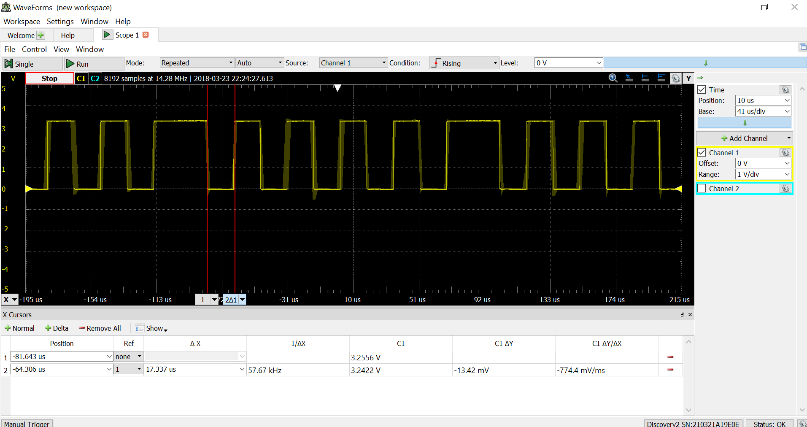

**Figure 1: USART Single Bit Transmission.**

**\*17.337 us= .000017337 s. Hz= bits per seconds. Baud rate=bits per seconds**

**\*1/(.000017227)=57680.1 =57600 Hz required in the doc**

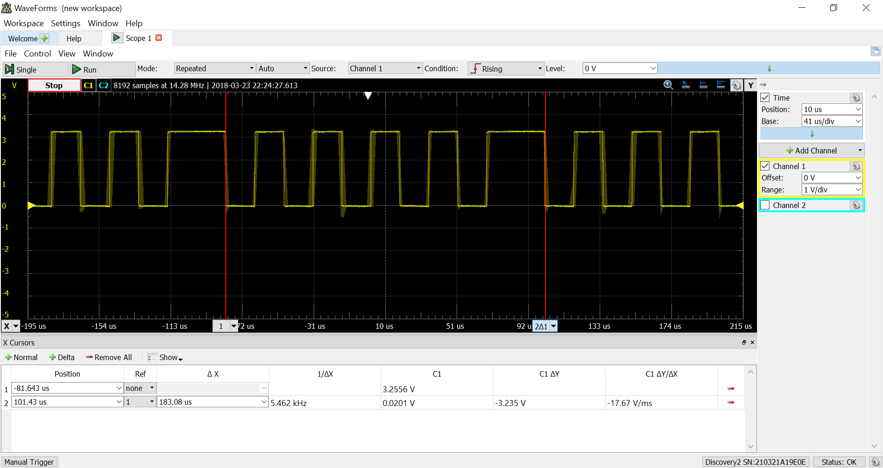

**Figure 2: USART Single Frame Transmission**

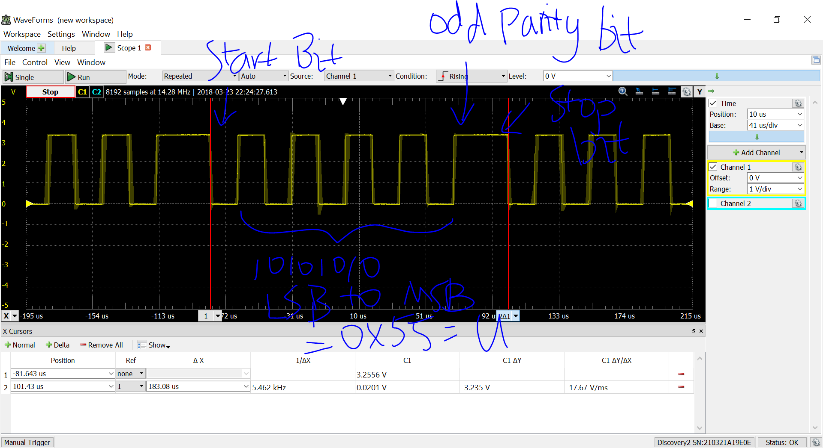

**Figure 3: USART Single Frame Transmission Annotated**

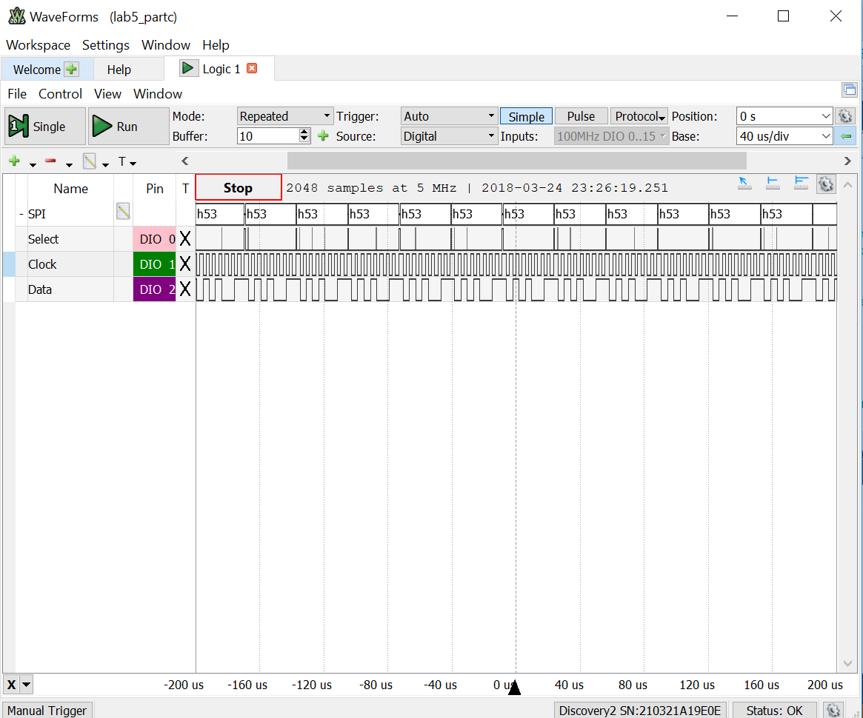

**Figure 4: SPI Transmission (Part C)**

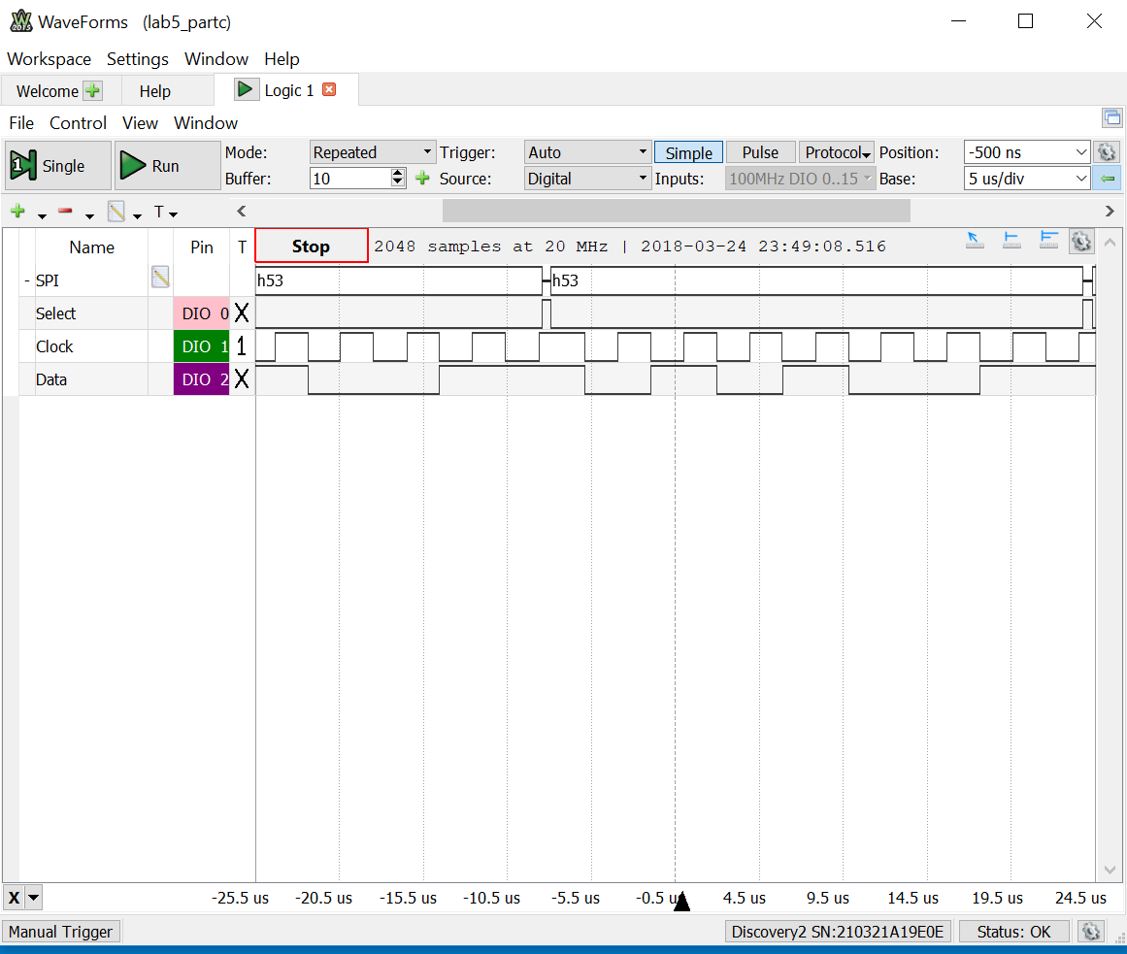

**Figure 5: SPI Transmission (Part C)- Close View**

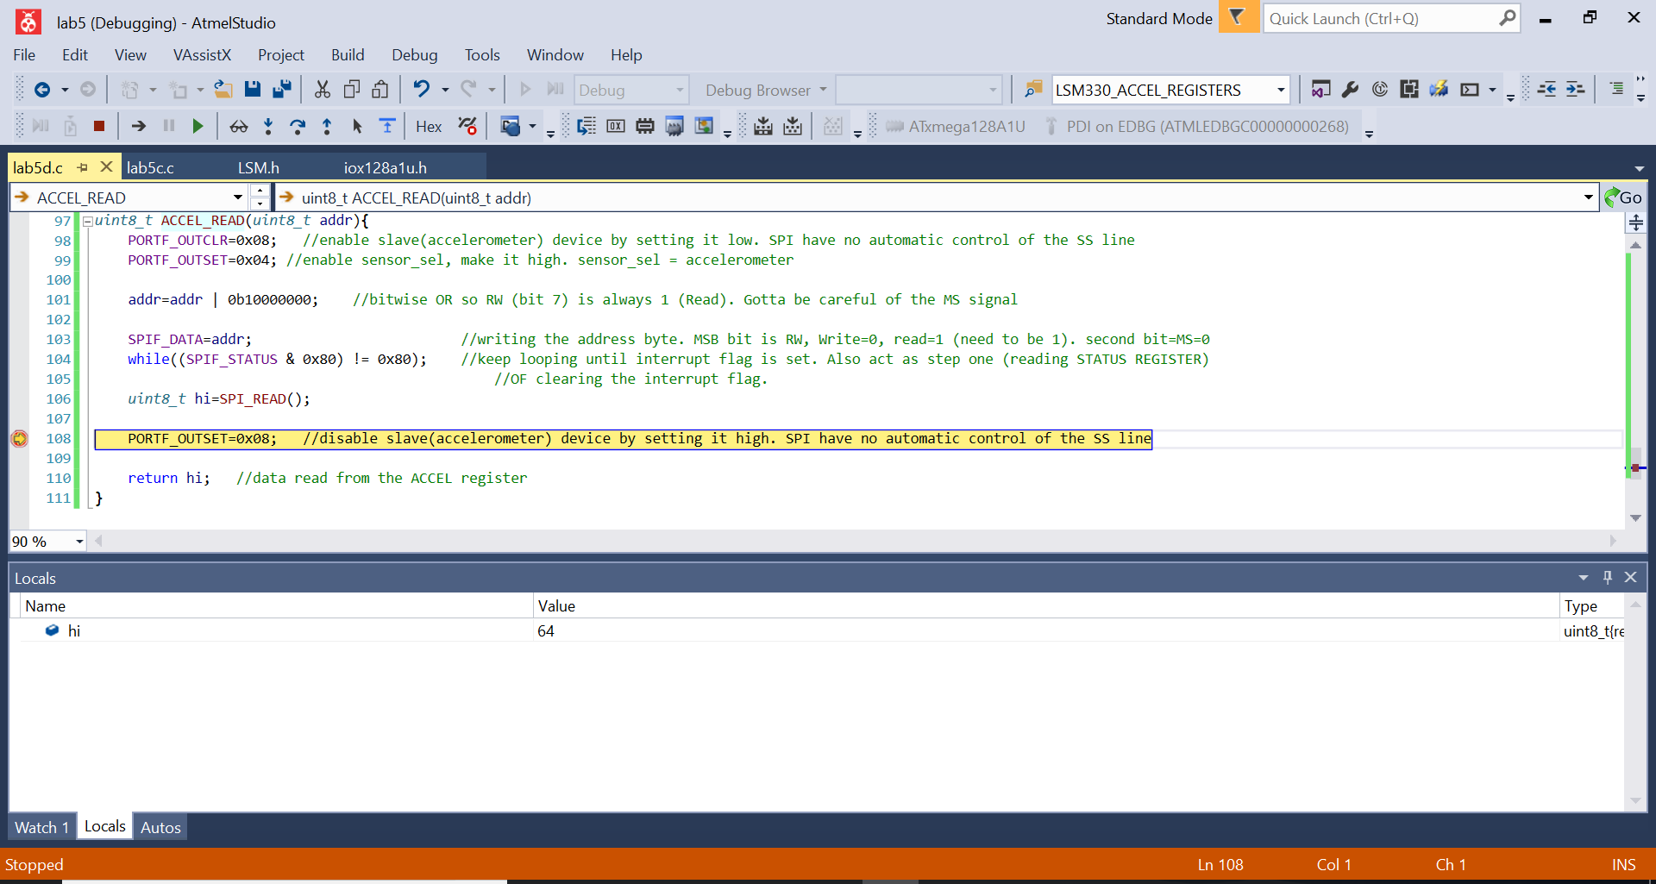

**Figure 6: WHO_AM_I_A register data confirmation. 64=0x40. (Part D)**

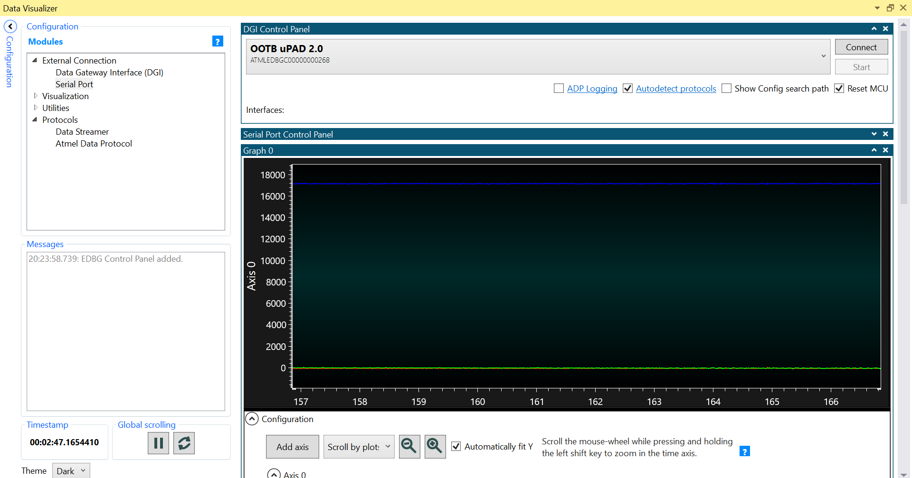

**Figure 7: Part F Real Time Plot Static View**

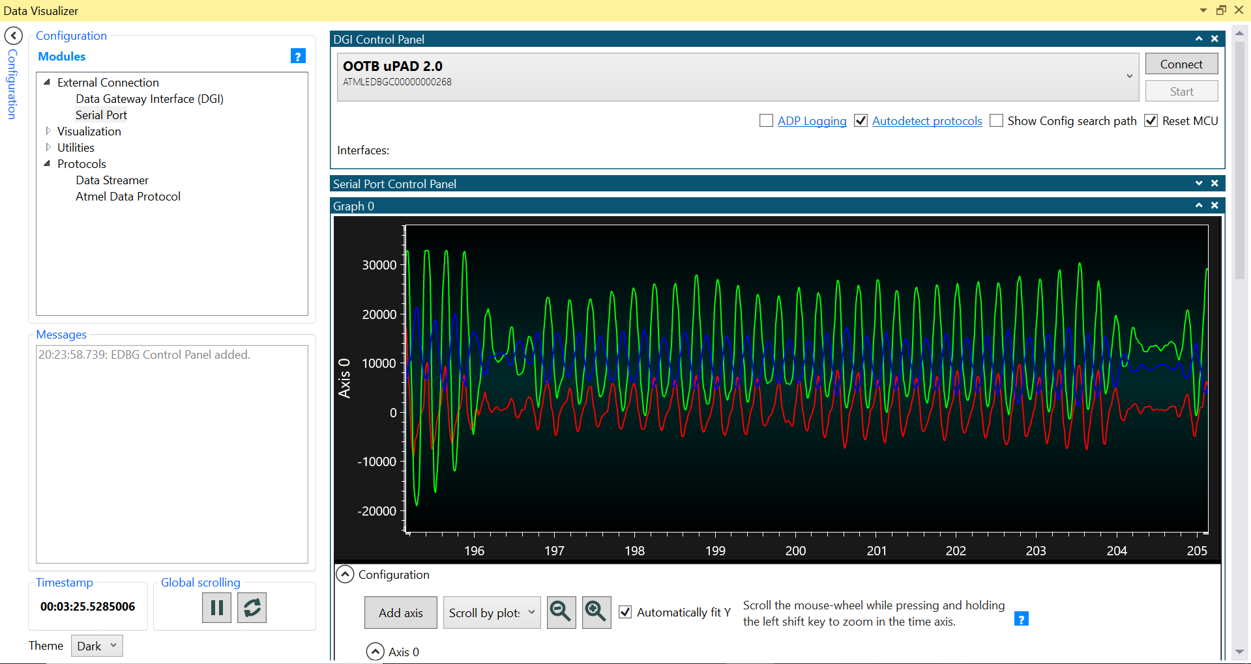

**Figure 7: Part F Real-Time Plot Dynamic View**